Oliver Collins-Cope

Unit 3 business in social media assignment 2

Richmond Upon Thames College

Contents

Introduction 3

Charity information 3

Goals for my campaign 4

Social media 4

Instagram 4

Target Audience 4

Gantt Chart 4

Social media policy 5

Content plans 5

Evidence of postings 6

Legal and ethical issues 6

Justify planning decisions 7

Researching Keywords 8

Optimising content (changing post times etc) 11

Following similar accounts 11

External feedback + Proof 13

Reviewing feedback 14

Reviewing data 15

Expanding on optimisation and for the future 17

Evaluation of Social Media Campaign 17

Changes for the future 18

Posting more often 18

Posting a variety of content 18

Including polls 18

Peer reviews 18

More information available 19

Instagram live 19

Adjusting and statistics 19

Comparison of target audience vs actual audience 19

Customisation and configuration of account/profile 19

Profile picture 19

Name 20

Biography 21

Link 21

Category 22

Hidden words 22

# Introduction

This is my document/assignment regarding my social media campaign for the charity of my choice. The primary purpose of this is to document and evidence my social media campaign while also giving myself an opportunity to explain my decisions and choices, while also presenting an opportunity to review my decisions and optimise my social media campaign. Over the course of the next few months I will be showcasing my charity and the work that it does, both major and minor things, as well as promoting my charity in the hopes that it promotes awareness and information regarding them.

# Charity information

I am running this social media campaign for the charity “Stichting Strays Meet Holland”. This is a charity organization based in Holland and they rescue stray animals from Spain and Romania currently. They save a multitude of animals, from cats and dogs, to horses and ostriches. I am running a social media campaign for them as I believe it would help them to save more animals and the exposure from my social media campaign could lead to more donations and promotion regarding the charity, helping the animals. I feel very strongly about animals and therefore I decided this would be an adequate charity to try and help support, while also aligning with my personal beliefs.

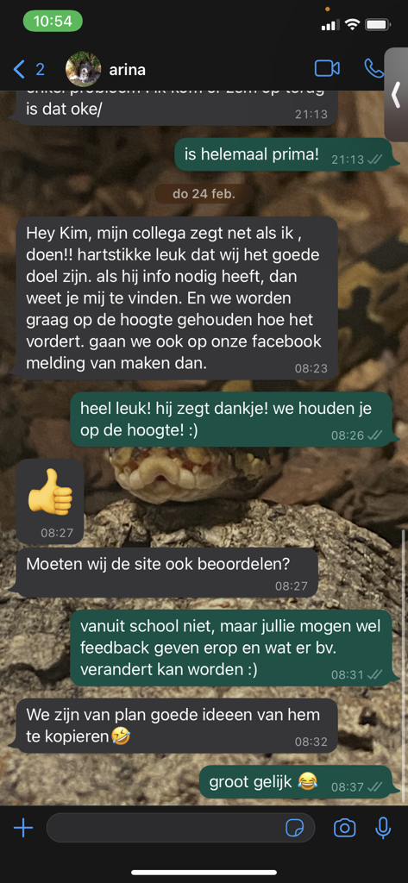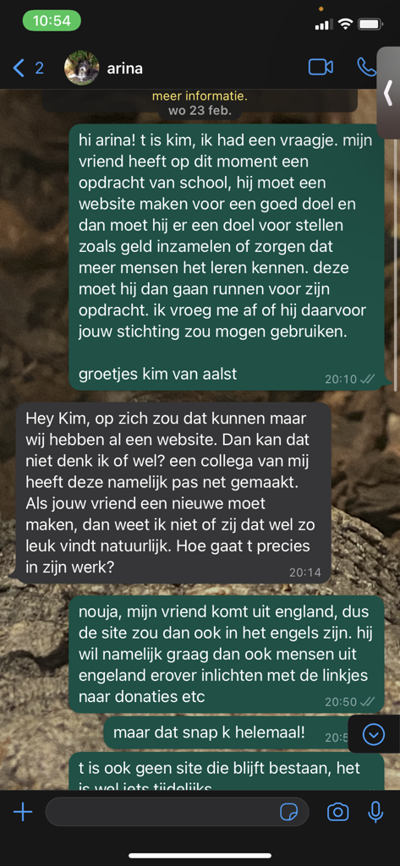

Here is evidence of me contacting the charity in order to gain permission to be able to post on Instagram and to make my website regarding the charity.

# Goals for my campaign

The primary goal for my campaign is to raise awareness through social media for my charity in order to create an online presence in the UK as this is a Dutch charity. I will do this through posting content, that is approved, on Instagram using the support of the business features that I discovered through my last assignment. I hope to gain at least 10-30 followers and at least 10 likes per post, with 1 comment that will be about the charity, while also hoping for the chance to be shared by other Instagram users as this will increase my exposure and increase the amount of attention the charity will receive in the UK.

# Social media

## Instagram

I will be using Instagram for this social media campaign as it offers many options for business accounts which any user can make. This includes post analytics, post scheduling, censorship, and many more key features that are easily accessible and easy to understand, allowing for efficient implementation of these features and optimisation of the account. In addition to this, the largest age demographic of Instagram – 18-34-year-old – has been found to donate more to charities than other age groups. (The Guardian, 2017)

## Target Audience

My target audience are users between 18-34 as this age group is the highest age demographic of users for Instagram. Furthermore, users between this age group are more likely to be sympathetic to a charity about animals and be more willing to donate generously towards charities, especially ones that are easy for users to sympathise, such as animals. Furthermore. studies have shown that millennials of this age group are also more careful with donations, which means that being able to promote this charity with genuine effort and through my own genuine support of the charity while also including helpful information, users in this age bracket will be more likely to donate. (The Guardian, 2017)

# Gantt Chart

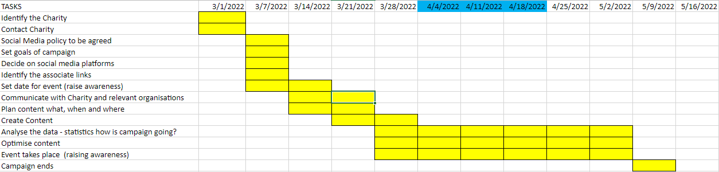

This is my Gantt Chart which is my general plan for my assignment. It spans the whole of the given time, with space at the end to write for my assignment and post what my Instagram page has done for my charity. It is broken up into different parts of the assignment, with the different tasks being completed in the allotted timeframe. Each square represents a week of real time, giving me adequate time to complete the tasks in the given timeframe and ensure that my social media campaign runs smoothly and on schedule.

I plan to run my campaign from the 28th of March to near the end of April – April 21st – in order to allow myself time to write my assignment and work on other projects in the works.

# Social media policy

For my social media policy, I have been in contact with the Charity and although there has been no specific policy, my content and my posts will remain professional and my language will be sophisticated. Furthermore, the content I post will remain informational and relevant to the charity in one way or another, and will stick to this across the whole page.

On my social media page, I will include filters in order to limit the kinds of comments people can leave on my posts, for example I will exclude swear words and slurs so users cannot comment that underneath my posts.

To further establish my social media policy, I will ensure that all content posted

# Content plans

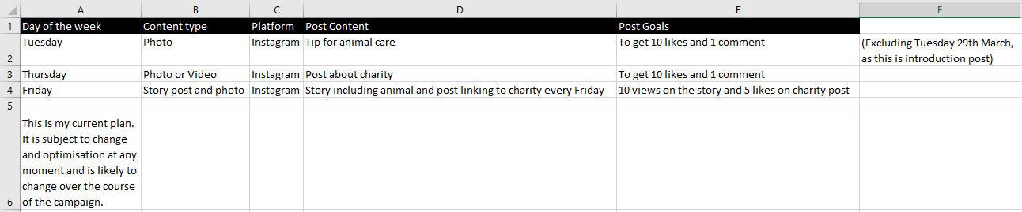

This is my content plan. I have chosen these three days of the week in order to ensure that my posts are spread out and not focused on the start of the week. I am posting at the end of the week in the evening in order to garner the attention of pet owners once they are done with their work week as I believe this has the highest chance of catching their attention.   
I have chosen these content types as I believe that they are a variety of post types and they will help to catch the user’s attention with the spread. Furthermore, the actual content of the post changes from every post in order to maintain the user’s attention.

My content plan and Gantt chart together make up my plan for my business (awareness for Strays Meet Holland) and aim to meet the requirement of raising adequate awareness for the charity based on my goals I previously set.

I made efforts to review my plan with my Unit lead where we discussed my plan prior to Easter and make any adjustments necessary. My unit lead was happy with my plan that I had made and approved it, allowing me to continue to posting quite early on, which gave me more room to do other things.

In addition to completing this assignment, I had to manage my other tasks and assignments, so I allowed myself roughly 4 hours of work a week on U3, which I spent reviewing content and adjusting my content plans depending on what was needed. This meant when planning for my social media campaign I had to include time for other assignments alongside it, which I made sure to do.

# Evidence of postings

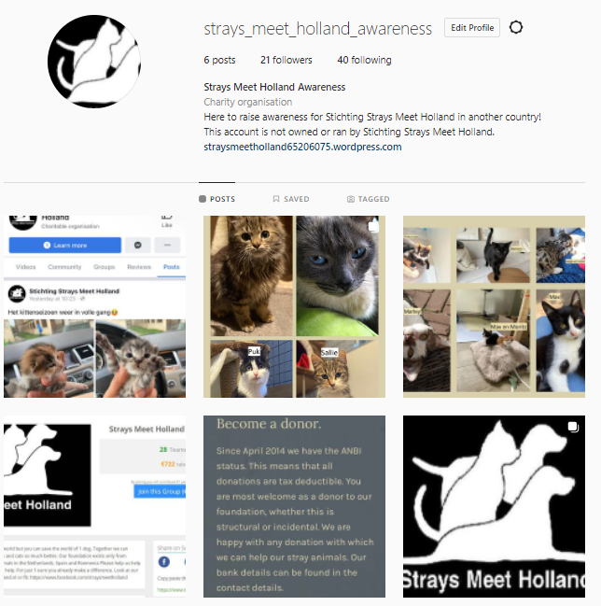

These are the posts that I was able to make over the course of the social media campaign.

# Legal and ethical issues

Some of the legal and ethical issues that occur when posting the content I have, could be copyright issues, however I have been given permission from the charity to make the posts that I made and to use the content I did in order to raise awareness for Strays Meet Holland.

Some other legal issues that I may have run into might have been some copyright issues if I had posted other content that I did not have permission for, or introduced music that was copyrighted. Fortunately, I had permission to post what I did and that covered the legal aspect of my site.

Regarding ethical issues that I have to consider, this means that all the content I produced and posted had to be appropriate for what I was posting and the charity I was promoting, as well as considering the potential comments that my viewers could leave, which I restricted to safe comments by using Instagram’s “custom words and phrases” to add words that I did not allow on the page, so as to not harm Strays Meet Holland through my page.

# Justify planning decisions

To justify the decisions I made in my plan, I made sure to extensively research the social media site I used and used my previously knowledge based on my first assignment. This includes the statistics I discovered regarding Instagram’s userbase and the intended users of my social media page.

As shown below, the most active userbase on Instagram is 18-24, and 25-34 and this is therefore my intended target audience, with a higher focus on 25-34-year old’s, as they are shown to be more charitable with their money, and have a higher chance of having developed financial stability and therefore the liberty to spend their money on charities they support and believe in. (The Guardian, 2017)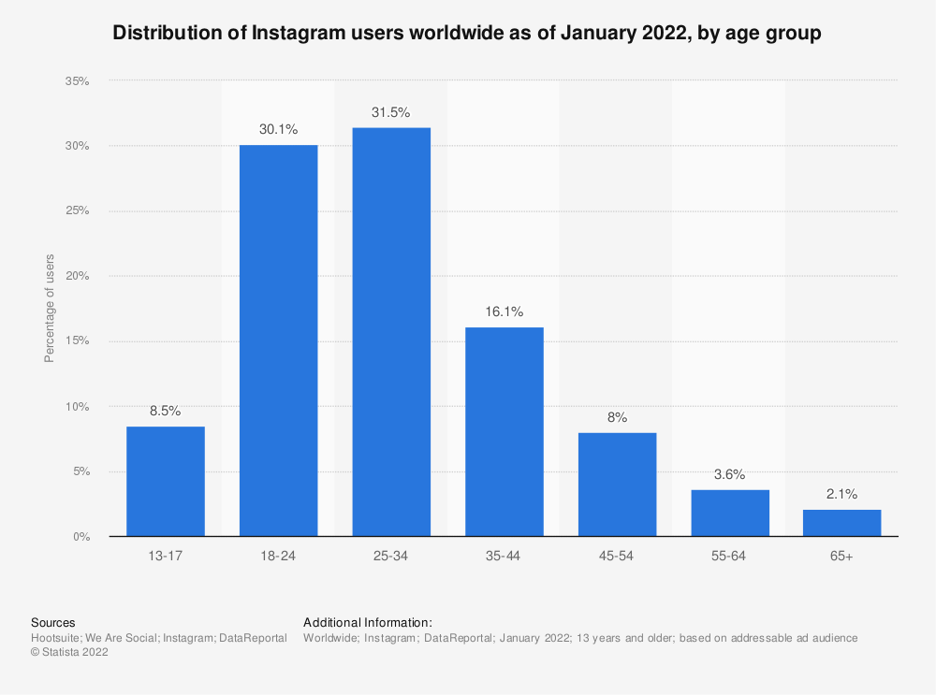

(Statista, 2022)

With regards to my posting days, those were chosen as I thought that it would be good to spread out my content across a few days, so as to not clutter up my followers feed and provide an enjoyable experience for my followers.

As seen in this source, it is better to spread out and contain social media posts in order to build a more genuine connection with followers and to allow authentic content.

“*Social media spam can clutter your brand’s message and prevent you from accomplishing your marketing objectives. By keeping social media spam in check, you can focus on posting authentic content, forging genuine connections with followers, and making progress toward key social media goals.”* (Sonnenberg, 2020)

# Researching Keywords

Some of the keywords I researched can be viewed through the hashtags of my posts. I chose keywords that I found had a high amount of posts, and related to my content and what I was supporting in order to maximise interactivity with my Instagram page.

These were my hashtags:

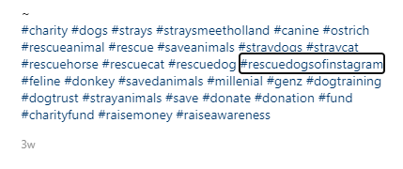

And here are some examples of the amount of posts for some of the hashtags I used.

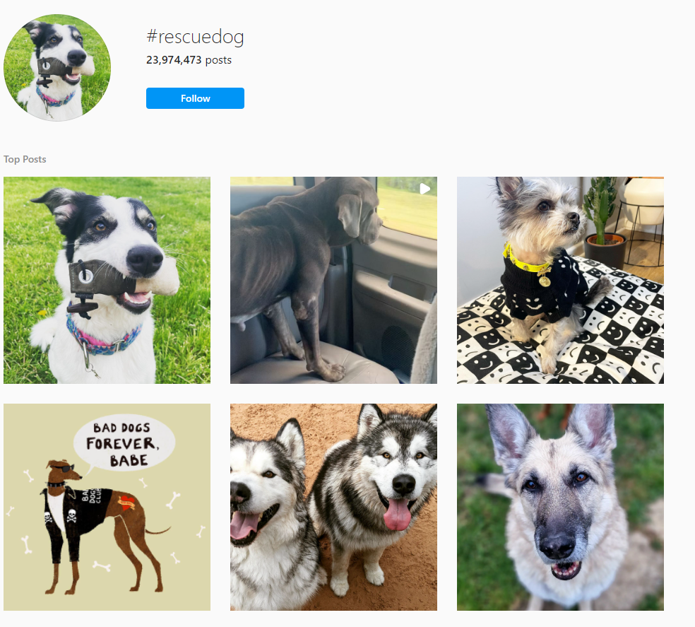

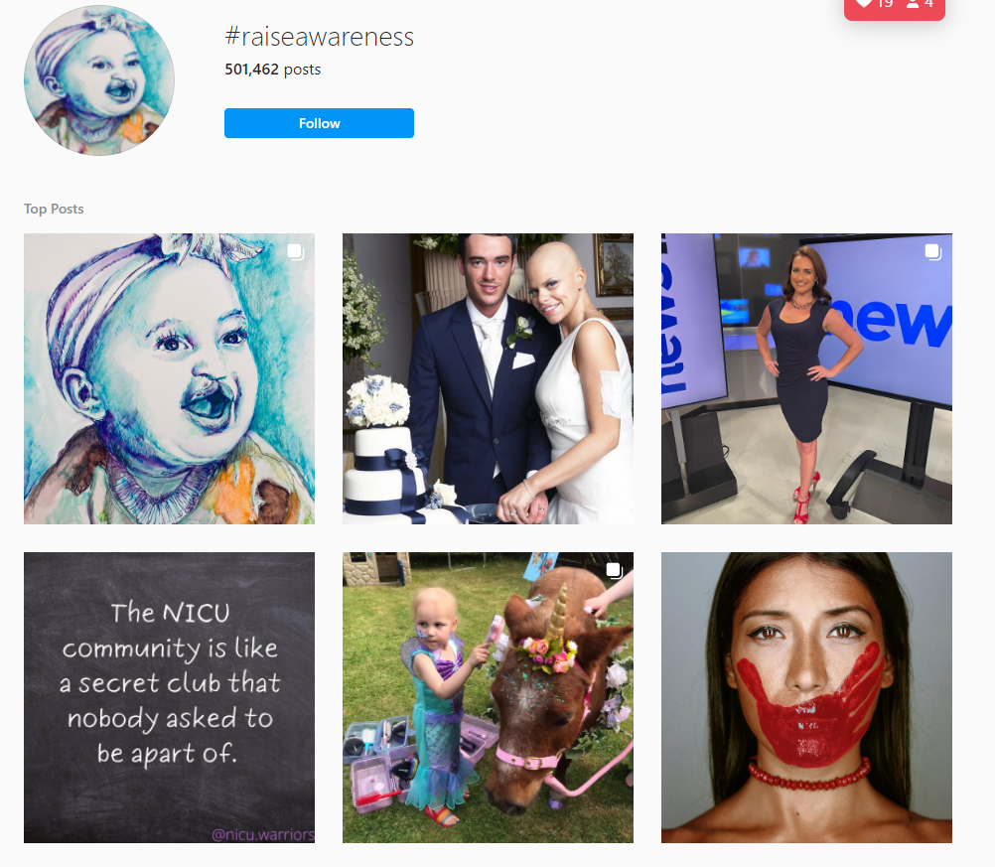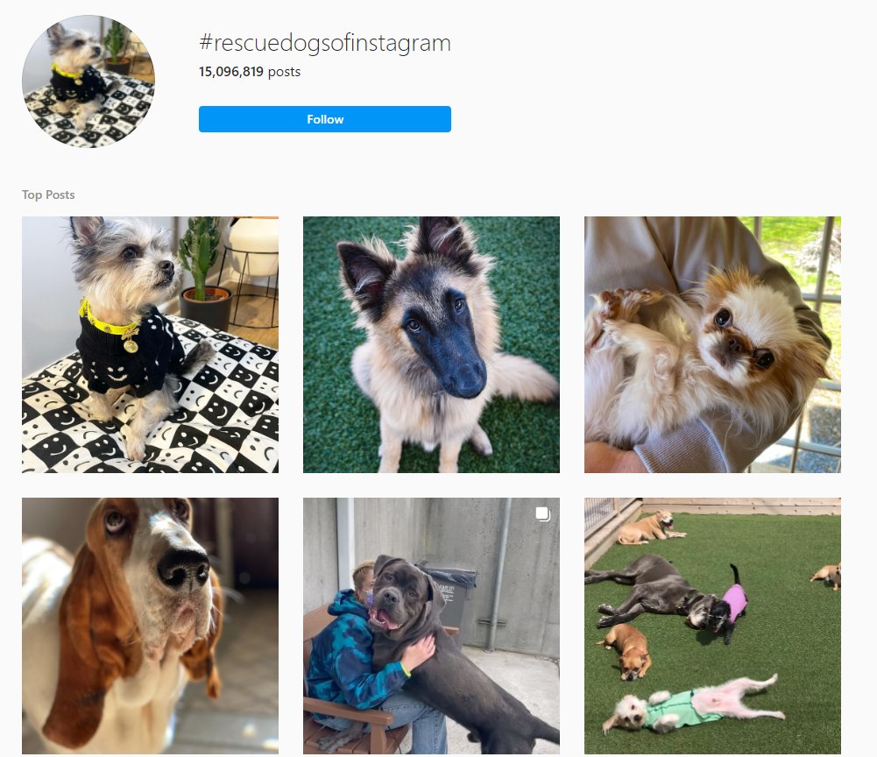

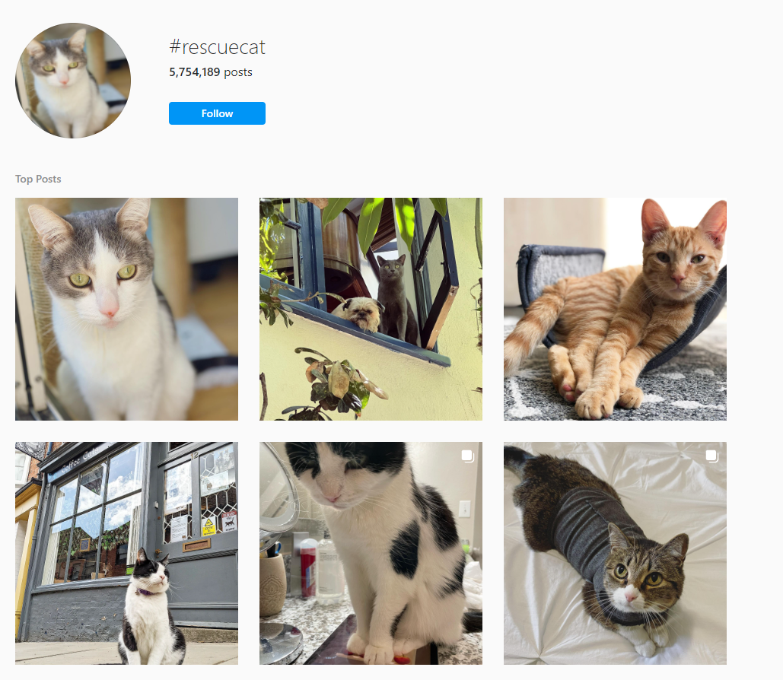

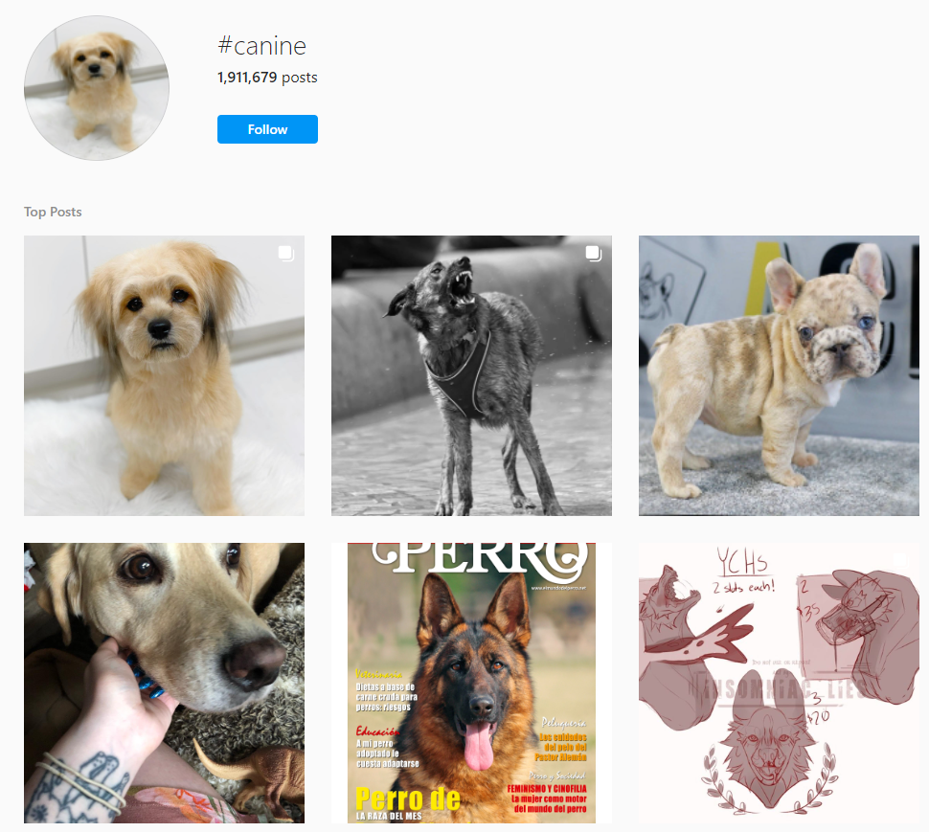

Almost all of my hashtags had over 100,000 posts, with multiple having over 1,000,000 and some with over 10,000,000. These hashtags allowed me to expand the reach of my posts and reach more users.

# Optimising content (changing post times etc)

In order to optimise my content, such as by changing the post type and changing post times, I had to experiment. I did this by changing the times at which I posted from the middle of the day, to the much later evening, and there is a noticeable difference in my interactions with my post when comparing the two.

When I optimised my posts and changed the times at which I posted, I noticed that there are differences which can be documented, and they have been below, and further analysed.

This is further discussed in more detail in the “Reviewing data” section of this paper, which goes into depth about the effects of my optimisation and attempts with experimentation and different post times and such.

# Following similar accounts

To boost the reach of my account, I also tried to interact with similar accounts that had interest in pets and animals, which meant they had a high chance of being interested in saving animals.   
I started this by first liking a lot of posts that had animals in them. This was to modify my explore page to have lots of animals all over it, as seen below.

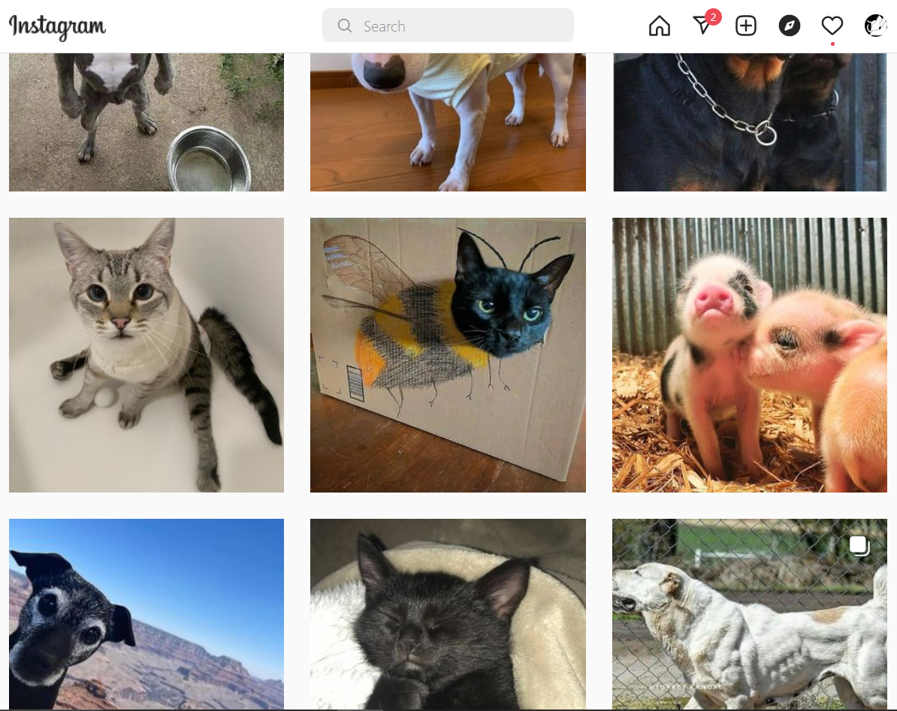

Once I had successfully done this, I then made the effort to follow animal type accounts in order for them to interact back with me, and to show up on other users page when exploring or searching.

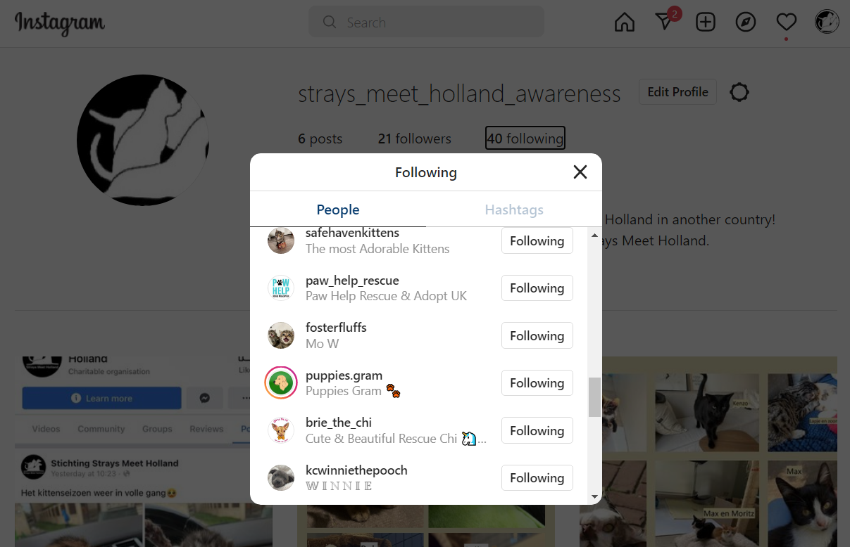

Of the 40 people I follow, roughly 30 are random Instagram accounts related to animals which I used as a method to boost the amount of people that followed and interacted with my account.

Through this, I was able to gain more followers and therefore have more users interact with my page, which helped fulfil my goal of raising awareness.

External feedback + Proof

Based on all of this, I will ask for external feedback on what people think I should do, whether it be posting later or earlier, with consistency in my posting types or posting more variety, and other similar questions. I will receive this feedback in the form of a windows form which I can easily set up and screenshot for proof.

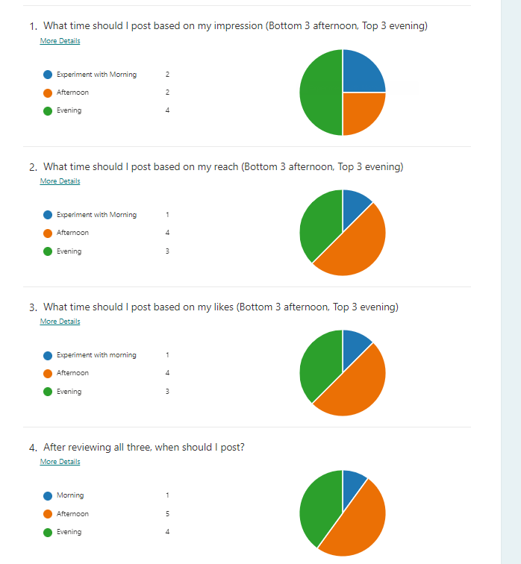

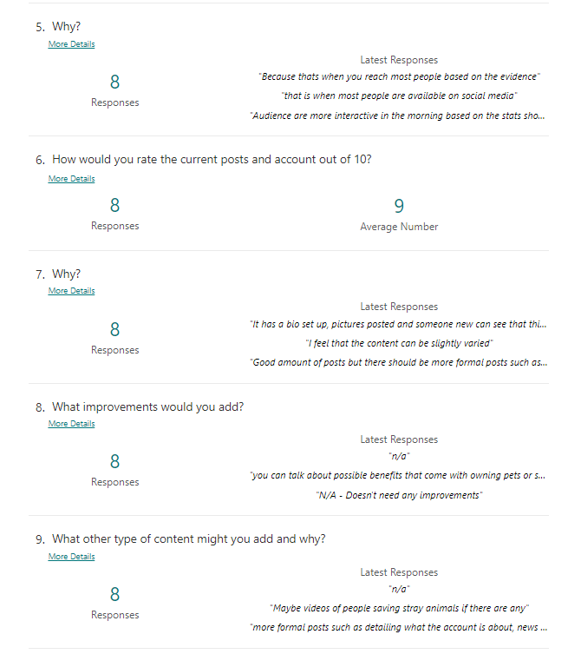

## Reviewing feedback

Based on the first screenshot and the feedback provided, in the future I would post more often in the evening, with occasionally varying and posting in the afternoons, with rarely any in the morning.

Currently, my account and the way it is setup has a high rating and therefore I would like to keep it the same way, however I do agree with the feedback that recommends more formal posts establishing the account and what it does.

Furthermore I would add more types of content that have a wider scope, such as posts regarding the health benefits of owning animals as suggested, and more formats such as videos in order to engage with the different users more.

# Reviewing data

My last three posts were posted later in the evening than compared to the first three, which were posted in the afternoon consistently.

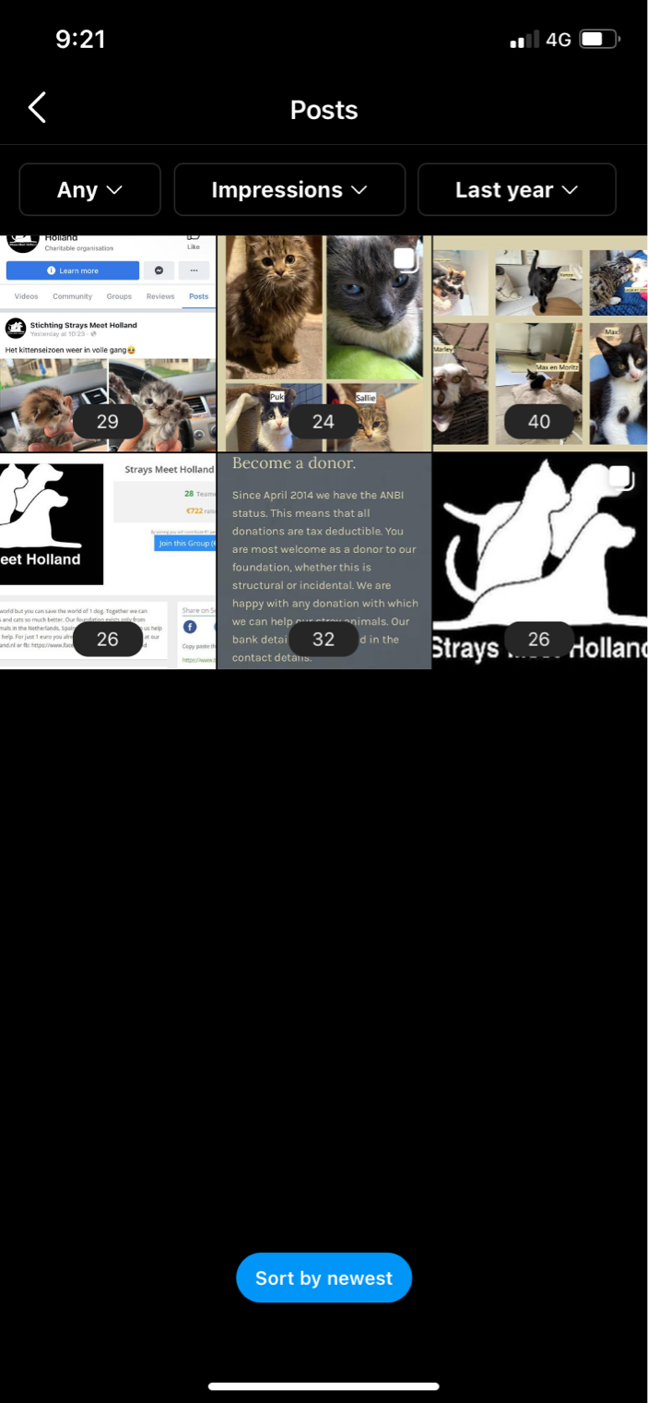

Impressions are “the number of times your content was shown to users, unique or not” (Hitz, 2021), and this means that my posts each reached this amount of users, regardless whether they had seen it before or not. Surprisingly, the latter posts had the highest number of impressions, with an average of 31 impressions, while the former had an average of 28 impressions.

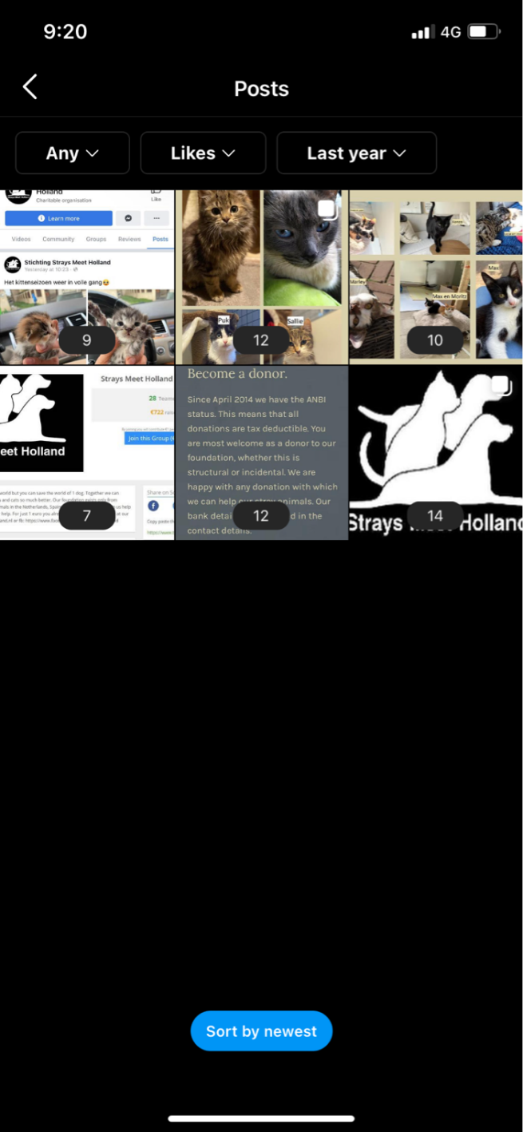

Likes refers to how many users liked my content and, also surprisingly, the former 3 posts had the highest individual likes on one post, with 14, even though it had the lower number of impressions. The former had an average of 11 likes while the latter three posts had an average of 10 likes, meaning that although the earlier posts had less impression on average, they had a higher like rate.

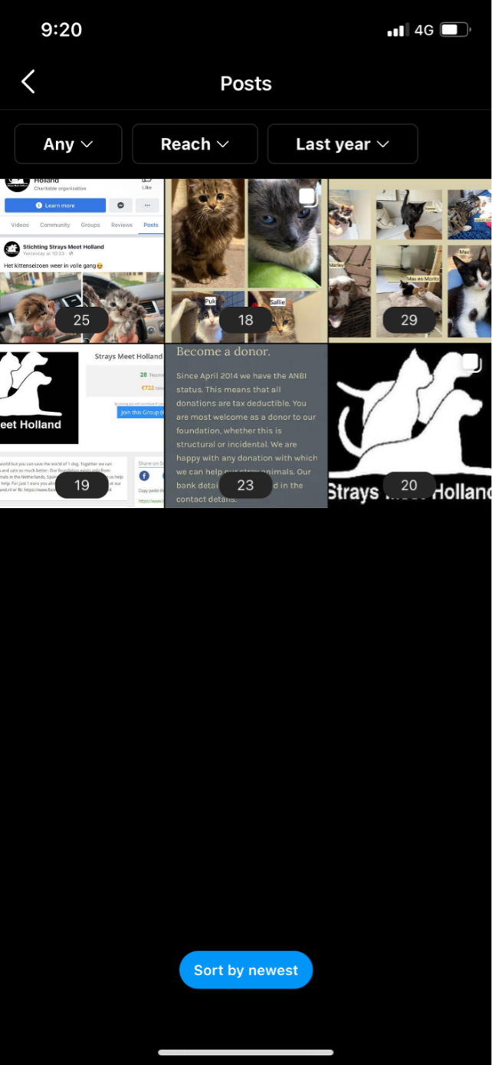

Finally, there is reach, which is “The number of unique users that saw your Instagram post or story on any given day” (Hitz, 2021), which means that each value counts for a single user. Contrary to the impression, the average reach of the last three posts is 24, as opposed to the previous 31 impressions. The former three posts average is 20, which is below the previous 28 impressions, meaning again that although the top three posts had the most reached unique users, they had the fewest average likes than compared to the first three.

Overall this means that although later posts have a higher reach and impression rate, there is a higher rate of interaction with earlier posted content. However, this could also be attributed to the fact that the more users reached, the higher chance that less people interact with the post.

## Expanding on optimisation and for the future

Considering the external feedback and the data I have reviewed internally, for the future I would like to post in the evening more often, with a more consistent posting schedule, while including a variety of different kinds of posts, not just regarding the charity.

One example of this is hoping to gain attention to my account through indirect advertising, where I could post a video showing the benefits of owning pets or adopting strays, including statistics and places where this could be done. This is called indirect advertising because I do not advertise the Strays Meet Holland charity, and instead I post about some of the things related to Strays Meet Holland, to expand my userbase and interact with different users, giving them more interest in my charity.

Something else I could do in the future would be to post stories with videos on my account, which I can then use to promote with my current followers more and possibly boost overall interaction with the Instagram account and charity website page.

Lastly, I would like to add more posts which more closely detailed posts about what the charity does and further in-depth information about how to support the charity.

# Evaluation of Social Media Campaign

To begin with my evaluation, I would first like to discuss and reiterate the original goal of my campaign as well. Initially, I aimed to achieve roughly 30 followers, and 10 likes on each post alongside 1 comment. Based on the data from my Instagram insights and looking at my account page, I did not fully achieve my goals, however I would still call my campaign a success. This is because I believe that my campaigns success should not just be measured with the original goals, and however with more realistic ideals and interactions.

I had hoped for my campaign to achieve all my goals, however I knew that the likelihood of it happening was not certain as there are a lot of factors to consider and there was always the chance of my page completely falling flat and not coming close to my goal. This is because there is never a certain chance of interaction with my pages occurring, and therefore I had to work to the best of my ability to ensure that my page has maximum exposure and reach. I believe that my campaign is a success as the primary goal of it was to “raise awareness”, which I believe that I achieved, as raising awareness does not require the interaction of thousands of individuals, “raising awareness” can count as just one user discovering the charity and interacting with my page, and therefore I would consider my campaign a success.

However, that does not mean that my campaign was without flaw, as there are many things I could have improved on and many decisions I would change if I was doing it another time. The experience I gained from this will prove invaluable should I ever attempt to do a similar project in the future.

## Changes for the future

For the future, there are several key changes that I would like to make, if I decided to keep posting or did another social media campaign.

These include, but are not limited to:

* Posting more often
* Posting a variety of content
* Including polls
* Peer reviews
* More information available about the account and charity
* Instagram live
* Adjusting based on post statistics

I believe that all these hold value that would greatly improve the quality of my Instagram page and any campaigns I would do in the future.

### Posting more often

This would be useful as more consistent posting would allow my Instagram page to grow faster and with a more widespread audience, as the chance of reaching new people grows with every single post and interaction.

### Posting a variety of content

I believe this would help grow any social media campaign as posting a variety of different kinds of content, such as videos or Instagram stories, would entice more users to interact and view the page as the content they can view is unique. Furthermore, posting videos alongside the standard photos and carousels people might already have posted, would introduce diversity and a higher chance of reaching a new audience which prefers viewing videos over standard images and carousels.

### Including polls

This is a great way to interact with the users that follow you and interact with your page. I would include this as it allows users to directly communicate with the page, and I could include questions asking things like what kind of content they would like to see and guide the page in a direction that appeases the users and boosts interactivity.

### Peer reviews

I would include peer reviews consistently in the future as giving opportunity for others to provide input into my page and to get outsider perspective, which often results in ideas you had not even thought of in the first place. Therefore, I believe peer reviews would be crucial in the future.

### More information available

I found that amongst the feedback form I did, there were some comments concerning the charity and not being fully aware of what they did or what the account provided, so in the future to fix this, I would clearly introduce the Instagram account page, maybe with a video instead of a picture or maybe a story which remains on the page to introduce it clearly and in a friendlier way.

### Instagram live

A key feature I would use in the future would be Instagram live, which allows me to stream from my camera and interact with users live, where I could do things such as Q&A sessions or showcase different animals. The possibility with live content is vast and I would like to explore all those options in the future.

### Adjusting and statistics

In the future, instead of waiting until the end of my campaign to review statistics, I would do it as I am posting to stay up to date with my audience and find what works well, including posting at different times repeatedly to see what posts have the highest interaction rates, and what kind of content the users enjoy the most.

Based off this, I would then strive to ensure that all the content and timings of my posting are ameliorated, allowing for maximum user reach and interaction with my page, further making it more successful in the future.

## Comparison of target audience vs actual audience

Due to the lack of data available, I am unable to compare my target audience to actual audience, so in the future if I was to run another campaign, I would like to be able to gather enough data from my postings and followers to compare them to my target audience before I started my campaign.

From there I would like to delve further into it to attempt to discover why there was a difference, and how to cater to my actual audience instead of attempting to cater to an audience that does not exist.

## Customisation and configuration of account/profile

In terms of customization for my account, I implemented several features, such as a profile picture, a biography, and a few more. I will go through them below:

* Profile picture
* Name
* Biography
* Link
* Category
* Hidden words

### Profile picture

For my profile picture I used the logo for Strays Meet Holland to introduce people to the branding on Strays Meet Holland and to allow those who know about the charity already, an easy connection to avoid confusion.

My profile picture:

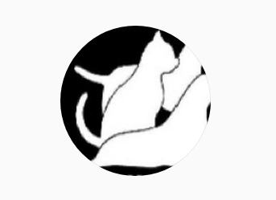

Strays Meet Holland logo:

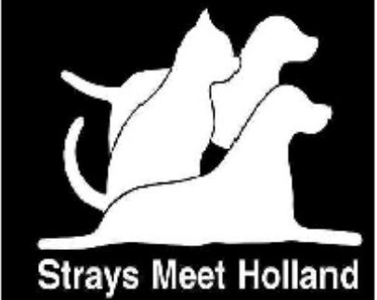

I believe this worked well as it is very clear what the profile picture is supposed to imply, and therefore I believe it was an effective feature to use for my social media campaign. Furthermore I had also received permission to do so, so I did not have to worry about the legality of what I had done.

### Name

I also established my name on Instagram as “Strays Meet Holland Awareness” to specify that my account is to raise awareness for Strays Meet Holland, and to try to already separate the idea that the account is run independently to the actual charity organization of Strays Meet Holland.

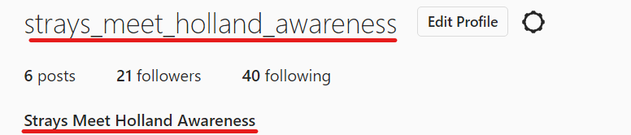

I believe that doing this was effective and useful as it introduced my page with clear naming and gave a feel for the account, as much as a name can.

### Biography

I included a biography on my account in order to create an area where users can get quick information about my page and the kind of content I will be posting, without them having to click on my posts and filter through all the different kinds of posts there might be, just so they can find a sliver of information that lets them know they are not interested. Furthermore, it also provides a space for people who are interested, to find out that this page aligns with what they are interested in, and it provides value to them.

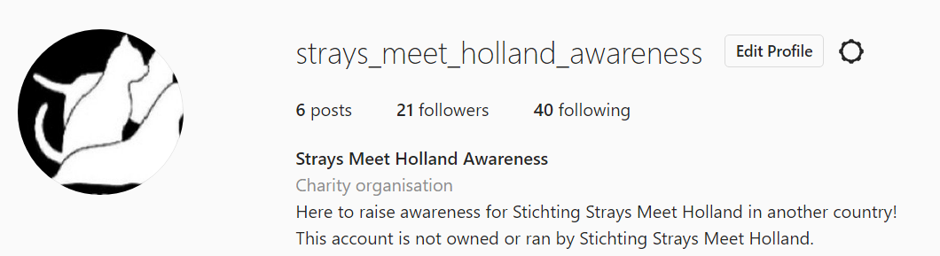

It clearly outlines that the goal of this account is to raise awareness for Strays Meet Holland and further, introduces a link for the user to find out more about the charity from the home page of the charity itself.

It also establishes that the account is run independently, and not owned by Strays Meet Holland.

I believe this biography was effective as it was short and concise, introducing the page and giving a brief description of what I was doing with my posts and the purpose of the account, however I do believe that my biography could have benefited from more detail in the description about Strays Meet Holland itself, and therefore in the future if I was to do another social media campaign, I would be sure to learn from this and introduce the account more.

### Link

As stated above, my account also provides a link to the charity, which users can click on to go and explore the page for themselves.

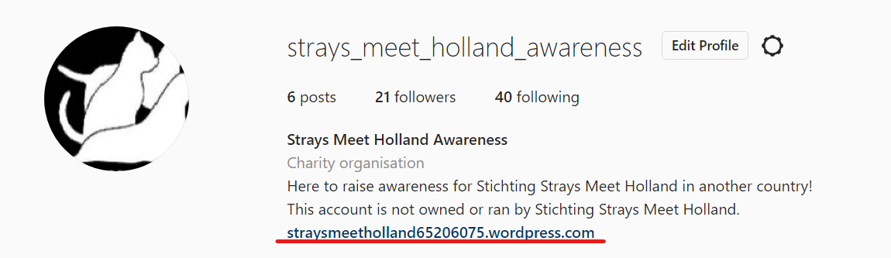

I believe this was an effective feature to introduce as it gave users a direct connection to the charity without them having to close off the application (Instagram) and search themselves, which would result in users not actually searching as it disrupts their time on Instagram. Therefore, by introducing the link, it is suddenly a lot smoother to go to the website, requiring nothing more than a tap to open it, and as a result has a much higher rate of interactivity than compared to if there was no link, and just a tap to close it.

### Category

As seen in the screenshot above, I also introduced the category for the page, a “Charity organisation.” I believe that although this is such a small feature, it is one of the most vital, as it clearly separates this account from others, labelling it a charity, which will illicit sympathy from users.

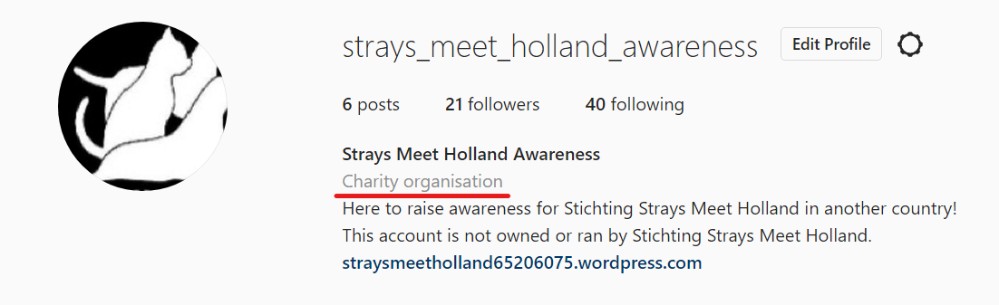

I evaluate this to be a good feature and a good use of it, as I believe this helps to elevate my account to a new level and separate it from other Instagram accounts.

### Hidden words

This refers to the feature of Instagram where I can add filtering to my comments and messages. Without a doubt, this is one of the most vital features for my social media campaign due to the fact that it prevents people from posting rude and offensive comments, and also gives me the opportunity to ban certain words I can choose myself.

I believe that this is an effective feature to use as it helps to protect the image of the charity and prevent bullying and harassment of the page and people who comment by protecting them before they even know something has happened. This is very useful and I believe that this has been a great feature on my page.

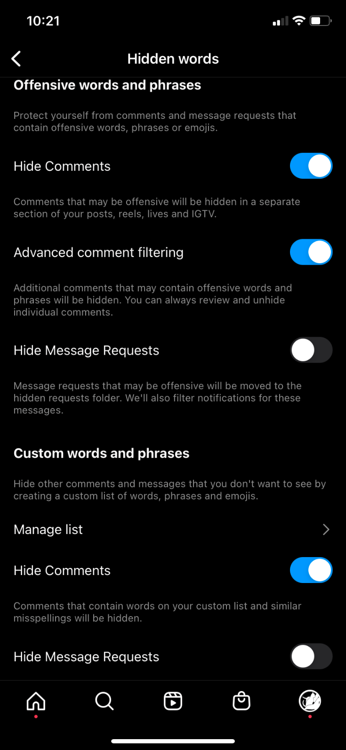

I will not show the custom words and phrases as there are unsavoury terms in there that do not belong here, however that helps get the idea across as to what kind of protection this feature helps to apply to my page.